Overview of Estonian economy

- Economic overview

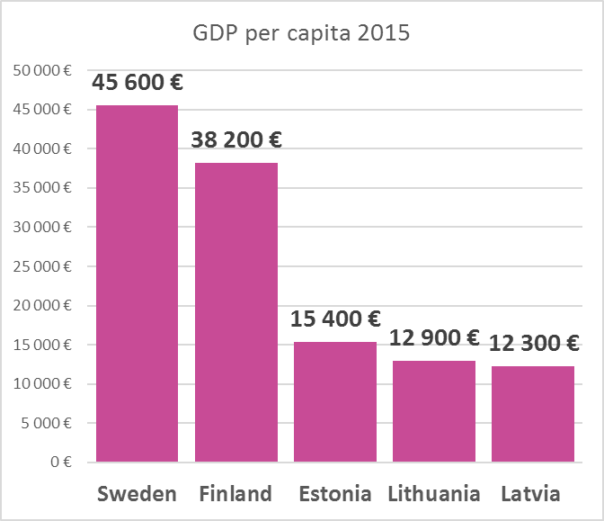
- 2016 GDP 21 bln € or 16 th € per capita. Prognosis for 2017 real growth is 4,3- 4,4%.
- GDP by consumption: households: 50.5% of GDP, government: 19.7%, investment in fixed capital: 23,5%, investment in inventories: 1.3%; exports: 78%, imports: 74%.
- Manufacturing makes 16% of GDP annually, wholesale and retail 12% and real estate 10% (construction another 6%).
- Export (goods and services): machinery and electrical equipment 22%, transport and warehousing 9%, wood and wooden products 7%, mineral fuels 6% (2016).
- Main economic partners: Finland, Sweden, Latvia, Germany, Lithuania and Russia.

- Resources

Work force
- 976103 inhabitants in working age (15-74).
- 704000 active inhabitants (employed or unemployed).
- Approx 49000 unemployed (7%), nr of vacancies 12000 (2nd q 2017).
- 76% of adults aged 25-64 within the OECD have completed upper secondary education (OECD average is 60%).
- Estonian students ranked 5th, Finnish 8th, Swedish 25th, Latvian 33rd and Lithuanian 38th in 2015 PISA test. Estonia ranked 3rd in science category of the test.
- Average gross salary 2016 was 1146 €/month and labour costs around 1550 €/month. Median gross salary was 865 €/month. Labor costs are higher than Latvia or Lithuania, but much lower than in Finland and Sweden.
- Education expenditures 4.7% of GDP in 2014. OECD average according to 2014 data is 4,4% of GDP, Latvia spent 4,4%, Lithuania 3,8%, Finland 5,6% and Sweden 5,2% of GDP.

Other resources
- 45228 sq km of territory, of which 22.2% agricultural land and 52.1% forest.
- Natural recources: wood, oil shale (põlevkivi), peat (turvas), rare earth elements, phosphorite, clay (savi), limestone (lubi), sand, dolomite, sea mud.
- Renewable energy 15% of all electricity consumption in 2016.

- Business environment
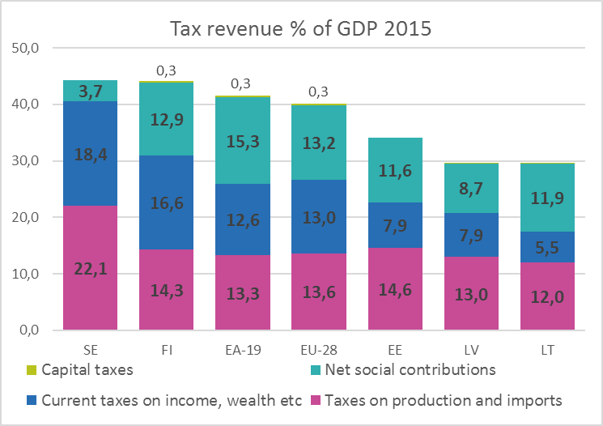
- Tax burden 2016 around 34,7% of GDP. Estonia ranked first in Tax Foundation’s 2017 International Tax Competitiveness Index.
- Estonia ranked 29th in World Economic Forum (WEF) Global Competitiveness Index 2017-2018.
- The World Bank ranks Estonia 12th in its Doing Business in 2017/2018 report.
- Estonia is on 6th place in region in The Heritage Foundation’s 2017 Index of Economic Freedom chart – 1st in EU. Estonia scored 79,1/100, Finland 74, Sweden 74,9, Latvia 74,8, Lithuania 75.8.
- Estonia ranked 32nd in public sector performance in WEF Global Competitiveness Index 2016-2017. Finland was 8th, Sweden 16th, Latvia 117th and Lithuania 87th.
- Corruption Perceiption index ranked 22nd being on the same level with France and Japan. Lithuania ranked 38th and Latvia 44th, Finland and Sweden 3rd and 4th respectively.
- Direct flights from Tallinn to 25-35 destinations, 512388 air passengers 2015.
- Member of WTO 1999, EU 2004, NATO 2004, OECD 2010, Euroarea 2011.

Economic prognosis of Estonian Ministry of Finance september 2017:
Indicator | 2016 | 2017 | 2018 | 2019
Nominal GDP (EUR billion) | 21,1 | 22,9 | 24,5 | 25,9
Nominal growth | 3,7% | 8,7% | 6,9% | 5,8%
Real growth | 2,1% | 4,3% | 3,3% | 3%
Consumer Price Index - CPI | 0,1% | 3,4% | 2,7% | 2,5%
Unemployment rate (% of the labour force) | 6,8 | 6,9 | 8,3 | 8,9
Average gross wage growth | 7,4% | 6,4% | 5,2% | 5,5%

